Supplemental content for: Power outages and cardiovascular and respiratory hospitalizations among US older adults

Supplemental Table 1: Distribution of power outage exposure by potential confounders for main analysis of county-level 8+ hour power outage exposure and CVD and respiratory hospitalizations in US 2018 Fee-For-Service Medicare beneficiaries.

Proportion of county-days with 8+ hour power outage affecting ≥1% of county customers by potential confounder quartiles
Wind speed
 | Quartile 1 | 0.009
 | Quartile 2 | 0.009
 | Quartile 3 | 0.010
 | Quartile 4 | 0.022
Precipitation
 | Quartile 1 | 0.013
 | Quartile 2 | 0.014
 | Quartile 3 | 0.012
 | Quartile 4 | 0.011
Daily maximum temperature
 | Quartile 1 | 0.022
 | Quartile 2 | 0.012
 | Quartile 3 | 0.009
 | Quartile 4 | 0.008

Supplemental Table 2: Rate ratios and 95% confidence intervals for the association between county-level 8+ hour power outage exposure and CVD and respiratory hospitalizations in US 2018 Fee-For-Service Medicare beneficiaries for outages affecting ≥1%, ≥3%, and ≥5% of county electrical customers. Estimates are from conditional Poisson regression models adjusted for daily wind speed, temperature, and precipitation.
CVD, cardiovascular disease; Resp, respiratory disease.

Power outage cut point | Outcome type | Lag day 0 | Lag day 1 | Lag day 2 | Lag day 3 | Lag day 4 | Lag day 5 | Lag day 6
1% | CVD | 1.002,  [0.99, 1.014] | 1.020,  [1.013, 1.026] | 1.023,  [1.014, 1.032] | 1.006,  [0.999, 1.012] | 0.988,  [0.98, 0.997] | 0.992,  [0.986, 0.998] | 1.009,  [0.997, 1.021]
3% | CVD | 1.016,  [0.999, 1.032] | 1.027,  [1.018, 1.036] | 1.027,  [1.015, 1.039] | 1.009,  [1.001, 1.018] | 0.993,  [0.981, 1.005] | 0.995,  [0.987, 1.003] | 1.009,  [0.993, 1.025]
5% | CVD | 1.025,  [1.005, 1.045] | 1.031,  [1.021, 1.042] | 1.029,  [1.014, 1.044] | 1.014,  [1.004, 1.024] | 1.000,  [0.986, 1.014] | 1.000,  [0.991, 1.01] | 1.010,  [0.991, 1.03]
1% | Resp | 1.025,  [1.012, 1.038] | 1.017,  [1.01, 1.024] | 1.009,  [1.003, 1.016] | 1.004,  [0.995, 1.012] | 1.000,  [0.993, 1.007] | 0.998,  [0.992, 1.004] | 0.997,  [0.985, 1.01]
3% | Resp | 1.052,  [1.034, 1.071] | 1.031,  [1.022, 1.04] | 1.013,  [1.004, 1.022] | 1.001,  [0.99, 1.012] | 0.997,  [0.988, 1.006] | 0.999,  [0.99, 1.007] | 1.004,  [0.987, 1.021]
5% | Resp | 1.067,  [1.046, 1.089] | 1.039,  [1.029, 1.05] | 1.016,  [1.005, 1.027] | 1.001,  [0.988, 1.014] | 0.997,  [0.987, 1.008] | 1.001,  [0.991, 1.011] | 1.009,  [0.988, 1.029]

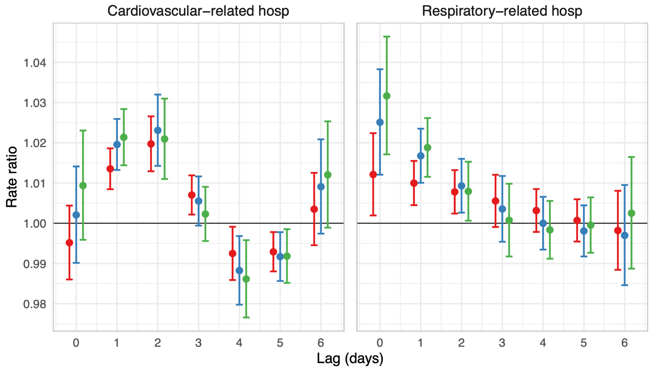
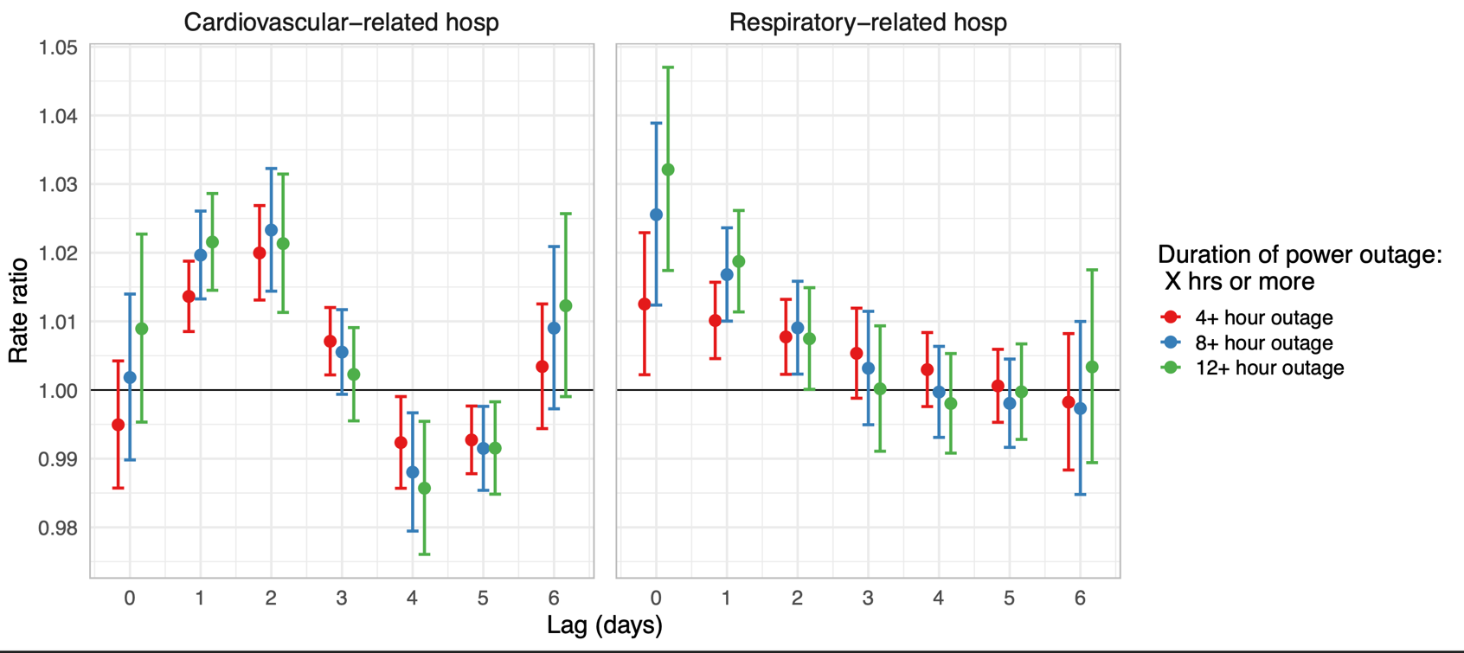
Supplemental Figure 1: Rate ratios and 95% confidence intervals for the association between county-level 8+ hour power outage exposure and CVD and respiratory hospitalizations in US 2018 Fee-For-Service Medicare beneficiaries for 4+, 8+, and 12+ hour power outages affecting ≥1% of county customers. Estimates are from conditional Poisson regression models adjusted for daily wind speed, temperature, and precipitation.

Supplemental Figure 2: Rate ratios and 95% confidence intervals for the association between county-level daily number of hours without power and cardiovascular- and respiratory-related hospitalizations in US 2018 Medicare Fee-For-Service beneficiaries. Estimates are from conditional Poisson regression models adjusted for daily wind speed, temperature, and precipitation. Results are from the best fitting model tested based on qAIC comparison, with a linear relationship between number of hours without power and respiratory hospitalizations or CVD hospitalizations, and 4 degrees of freedom on the lag dimension.

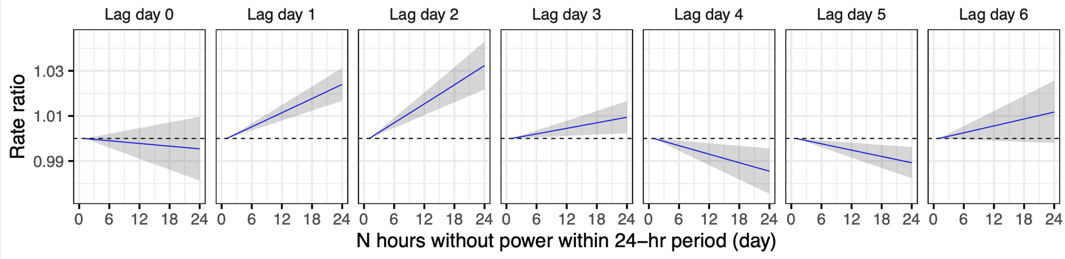
Cardiovascular-related hospitalizations
Respiratory-related hospitalizations
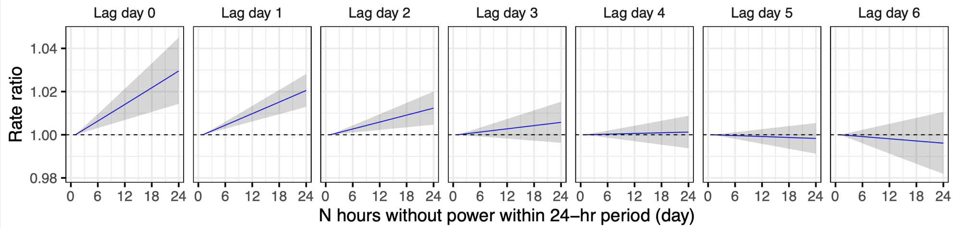

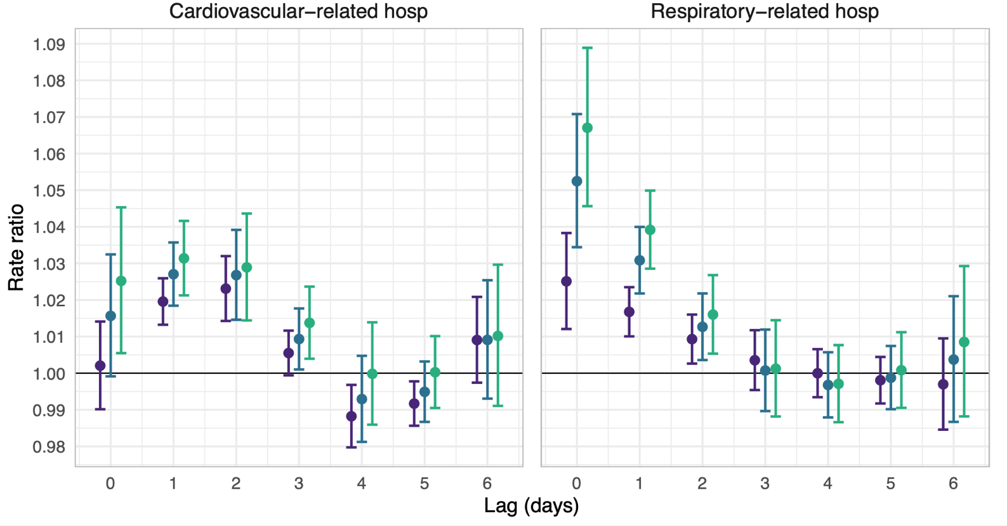
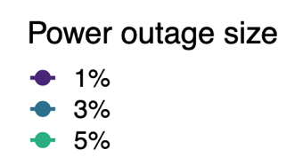
≥ 1%
≥ 3%
≥ 5%
Supplementary Figure 3: Rate ratios and 95% confidence intervals for the association between county-level 8+ hour power outage exposure and cardiovascular- and respiratory-related hospitalizations in US 2018 Medicare Fee-For-Service beneficiaries for outages affecting ≥1%, ≥3%, and ≥5% of county electrical customers. In this sensitivity analysis, instead of last observation carried forward, some missing values were replaced with 0. Estimates are from conditional Poisson regression models adjusted for daily wind speed, temperature, and precipitation.


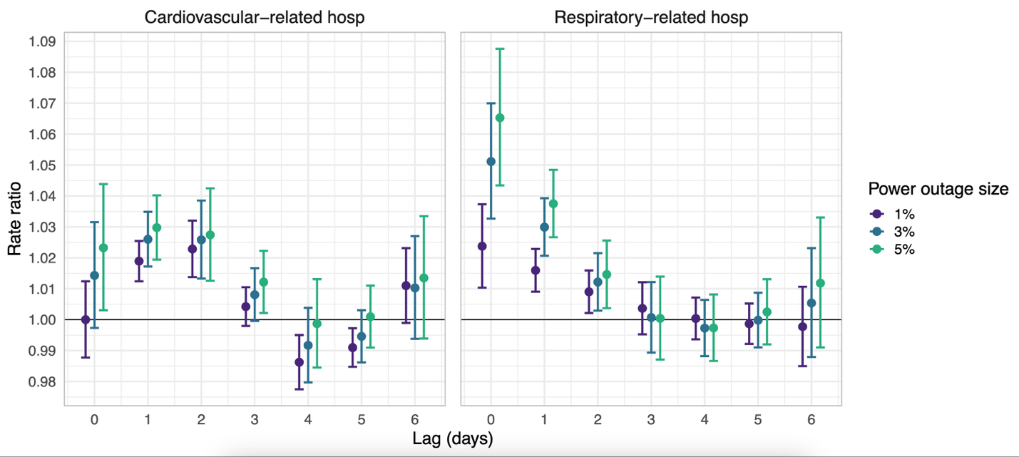
Supplemental Figure 4: Rate ratios and 95% confidence intervals for the association between county-level 8+ hour power outage exposure and cardiovascular- and respiratory-related hospitalizations in US 2018 Medicare Fee-For-Service beneficiaries for outages affecting ≥1%, ≥3%, and ≥5% of county electrical customers, in counties with 20% of data missing or less. Estimates are from conditional Poisson regression models adjusted for daily wind speed, temperature, and precipitation.
≥ 1%
≥ 3%
≥ 5%

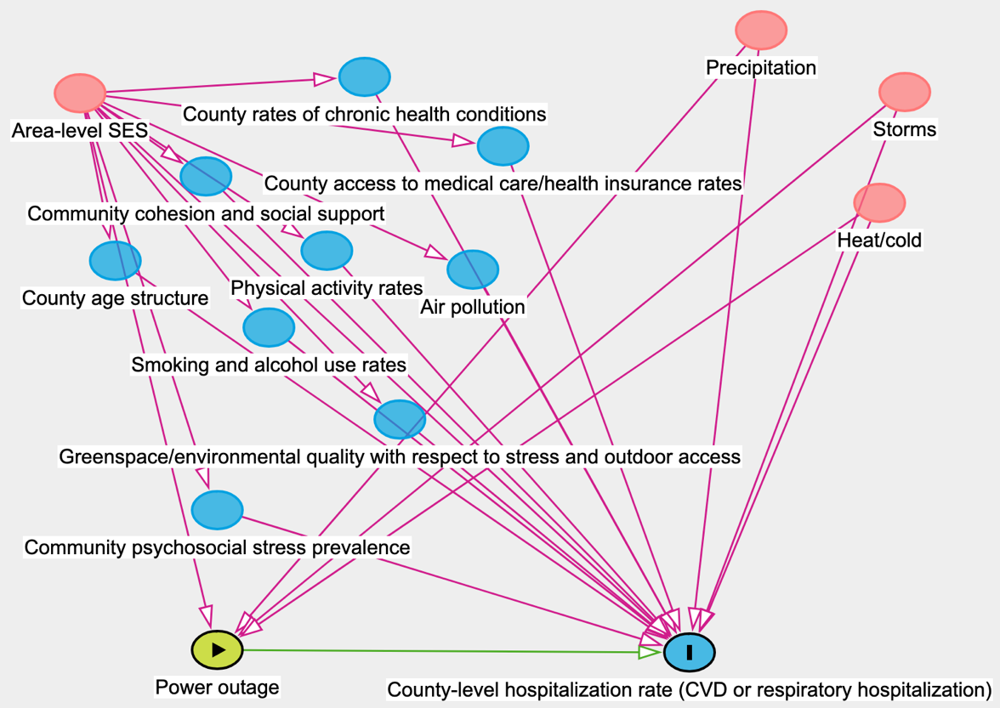

Supplemental Figure 5: Directed acyclic graph describing hypothesized causal relationships between power outage, hospitalizations among older adults, and potential confounders.

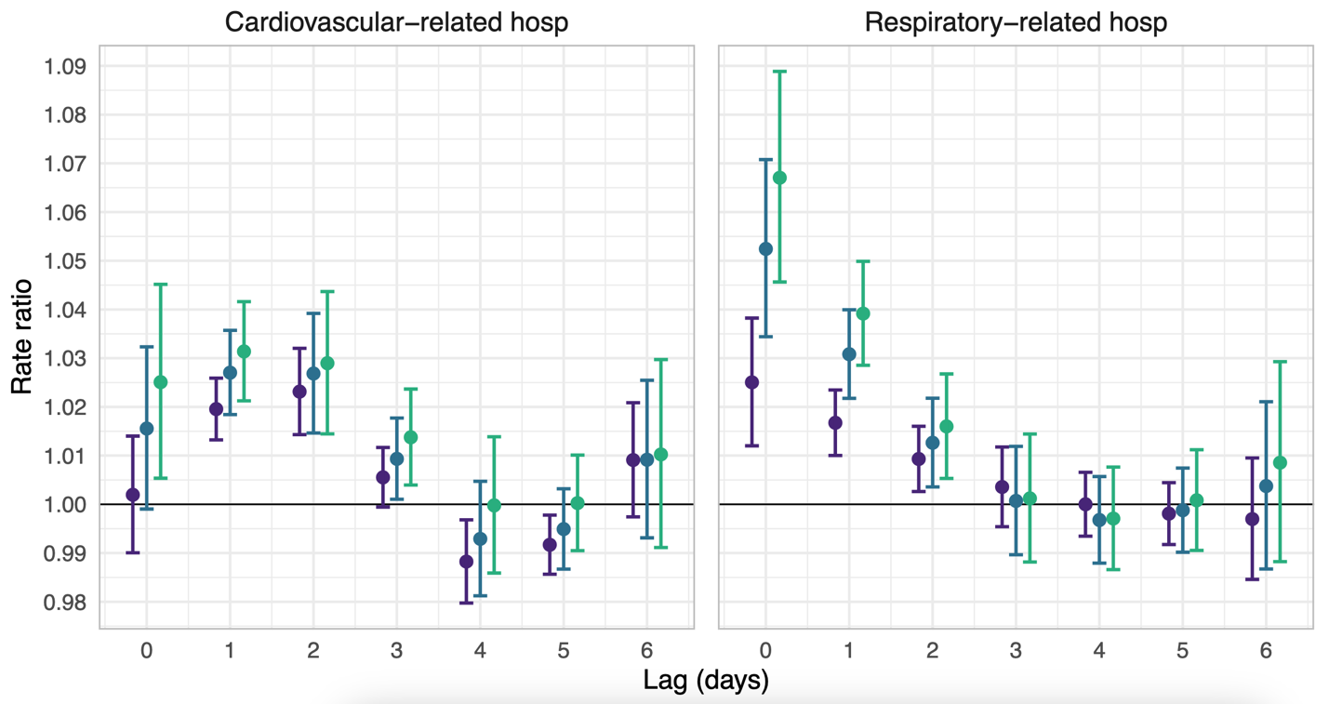



≥ 1%
≥ 3%
≥ 5%

Supplemental Figure 6: Rate ratios and 95% confidence intervals for the association between county-level 8+ hour power outage exposure and cardiovascular- and respiratory-related hospitalizations in US 2018 Medicare Fee-For-Service beneficiaries for outages affecting ≥1%, ≥3%, and ≥5% of county electrical customers. Estimates are from conditional Poisson regression models adjusted for daily wind speed, temperature, precipitation, and wildfire PM_{2.5}.

Supplemental Table 3: Rate ratios and 95% confidence intervals for the association between county-level 8+ hour power outage exposure and cardiovascular- and respiratory-related hospitalizations in US 2018 Medicare Fee-For-Service beneficiaries on anomalously hot and anomalously cold days. .Estimates are from conditional Poisson regression models adjusted for daily wind speed, temperature, and precipitation.

 | CVD hot | CVD cold | Respiratory hot | Respiratory cold
8+ hour power outage | RR = 1.03  95% CI: [1.02, 1.04] | RR = 1.04  95% CI: [1.03 1.05] | RR = 1.00  95% CI: [1.00, 1.01] | RR = 1.04  95% CI: [1.02, 1.06]
Anomalous temperature day | RR = 1.00  95% CI: [0.99, 1.00] | RR = 1.05  95% CI: [1.04, 1.06] | RR = 1.03  95% CI: [1.01, 1.05] | RR = 1.07  95% CI: [1.06, 1.08]
Power outage and anomalous temperature day interaction | RR = 1.06  95% CI:[1.02, 1.10] | RR = 0.96  95% CI: [0.91, 1.01] | RR = 1.02  95% CI: [0.97, 1.07] | RR = 0.91  95% CI: [0.85, 0.97]

